ORIENTEERING EVENT VILNIUS 2017,
BALTIC MTBO CHAMPIONSHIPS
The organizers are pleased to invite you to the traditional 3-day orienteering event in Vilnius. The event is held annually since 1991.
The event will be held together with the Baltic MTBO Championships.

ORGANIZER
Event organizer is Lithuanian Orienteering Federation, Vilnius municipality and orienteering club PERKŪNAS.
Event manager – Vytautas Ralys, head referee – Tomas Stankevičius, head secretary – Darius Sadeckas.

PROGRAMME
The competition will take place on May 5-7, 2017 in Vilnius and its suburbs.
Day 1 (May 5, 2017). Short distance. Start at 17:00, (MTBO – 15:30).
Day 2 (May 6, 2017). Long distance. Start at 12:00, (MTBO – 10:00).
Day 3 (May 7, 2017). Middle distance. Start of pursuit for foot-o groups at 11:00, (mass-start for MTBO at 9:30).

MAP AND TERRAIN
Day 1 (May 5, 2017). Karoliniškės, Vilnius.
The course will go through a district dominated by multistory residential buildings of various forms and arrangement, many open spaces and greenery.
MTBO course will also go through the eastern part of Pilaitė map (where 2015 Lithuanian MTBO National Championships Relay was held). Car traffic will not be restricted during the competition. Please remain cautious when crossing streets and roads. There is also limited visibility near building passages and courtyards. Terrain in the urban areas is flat, forest terrain is moderately hilly with slopes up to 20 meters high. There is a dense path network.

Scale 1:4000, contour interval of 2 meters. MTBO scale – 1:7500.
Mapped in 2017 by Vytautas Ralys and Tomas Stankevičius.
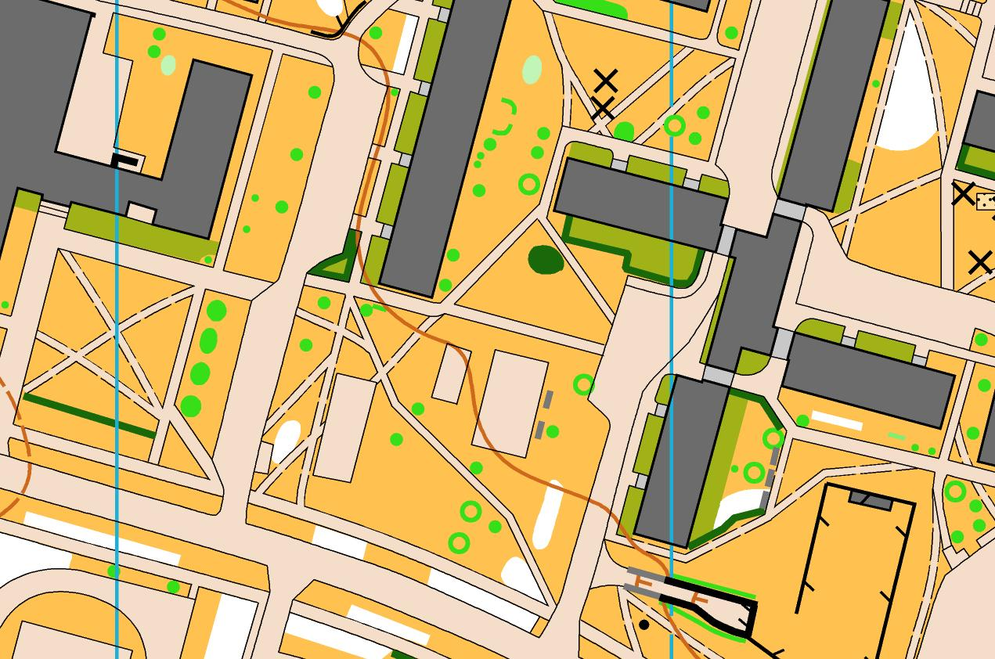
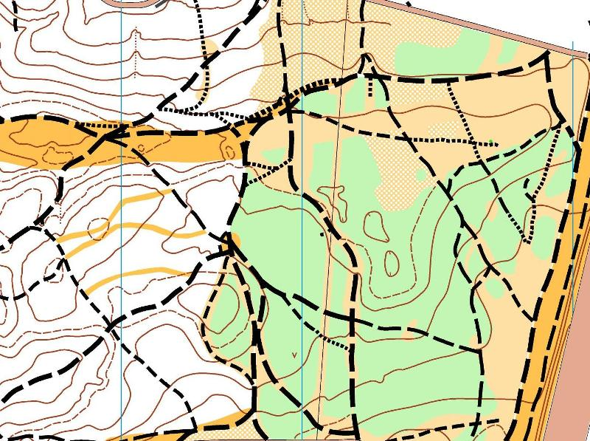
Day 2 (May 6, 2017). Šilėnai, Zujūnai parish, Vilnius district municipality (approximately 20 km from Vilnius center).
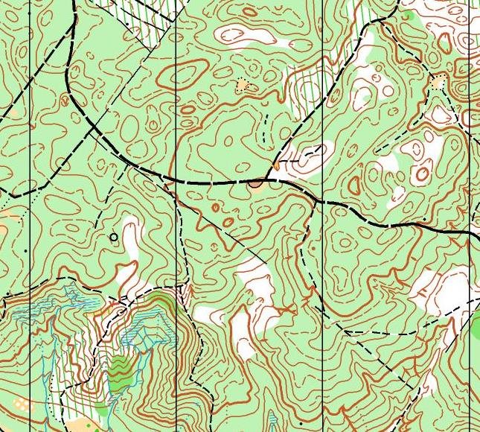
The course will go through a rugged forest terrain with many re-entrants, hills and depressions. There are slopes up to 70 meters high with wet ravines. The forest is mixed. Runability varies from good to bad, medium runability dominates.
Scale 1:10 000, contour interval of 5 meters. MTBO scale – 1:15 000.
Mapped in 2016-2017 by Audrius Smilgius and Egidijus Kukenys.

Day 3 (May 15, 2017). Giruliai, Zujūnai parish, Vilnius district municipality (approximately 16 km from Vilnius center)
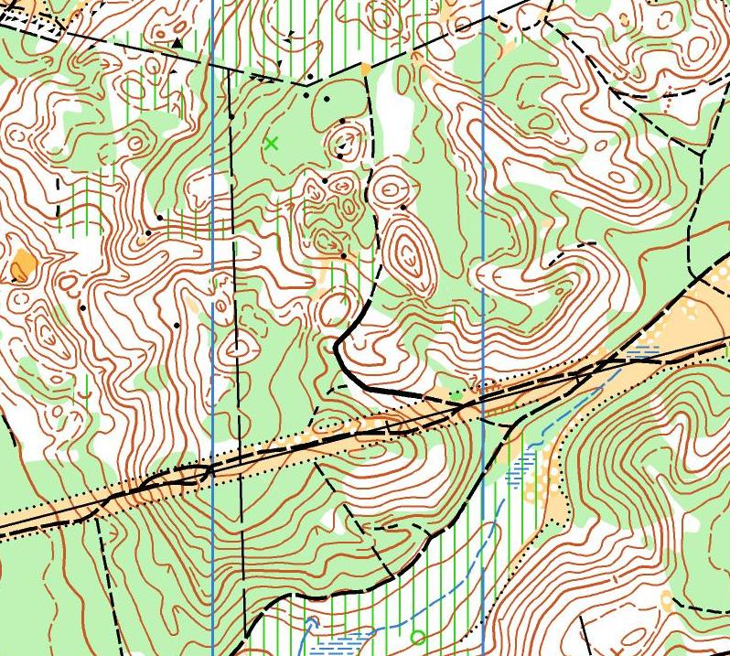
Medium runability forest. Relief varies from a very rugged with hills, slopes and ravines to areas of flat blocks. Sparse path and road network. There are areas with logging activities taking place.
Scale 1: 10,000, contour interval of 2.5 meters.
Mapped in 2016-2017 by Vytautas Tamulionis.

CLASSES
Competition will be held in these classes:
M/W 8, 10, 12, 14, 16, 18, 20, 21E (elite), 21S (short), 35, 40, 45, 50, 55, 60, 65, 70.
MTBO classes: MBWE (women elite), MBME (man elite), MBWA, MBMA, MBW14, MBM14, MBW17, MBM17, MBW20, MBM20, MBW40, MBM40, MBW50, MBM50, MBW60, MBM60.
Open (an open class with no entries in advance and no start lists).
M/W 10 – standard (point-to-point) course in an urban area on the first day, marked course with controls on the marked line (the marked line both set in terrain and drawn on the map) second and third day.
M/W 8 – course with a special map at the finish area. Children can run it with parents. Start time is free.

In case there are less than 5 participants in one class, the organizers have a right to join classes.

PUNCHING SYSTEM
SPORTident AIR+ for all classes. SIAC cards are mandatory for all MTBO classes.
SPORT Ident SIAC and SI card rent: M/W8-18 – 0.5 € per day, other classes – 1 € per day. Number of SIAC cards for rent for foot-orienteering is limited. An intention to rent a SIAC card MUST be specified in the comments section of the entry form. In case of lost or not-returned card, the competitor must refund, accordingly, SI or SIAC card price.

PRIZES
The winners will be determined by summing up the total time of the 3 days.
Prizes will be awarded to the top 3 competitors in each class (in M/W21E classes – to the top 6 competitors).
The winners of Baltic MTBO Championships will be determined for each course separately.

ENTRY FEES AND PAYMENT
On-line entry form: http://www.dbtopas.lt/takas/en/varz/
You can also send an entry by e-mail okperkunas@gmail.com (name, surname, club, country, class, SI card number, and other necessary information).
ENTRY FEES | W/M  8 | W/M  10-18 | W/M  20, 70 | W/M  21-65 | MTBO 14-17 | MTBO 20 | MTBO 21-60
before April 26, 2017 | 8 € / 3 € per day | 11 € / 4 € per day | 17 € / 6 € per day | 27 € / 10 € per day | 15 € / 5 € per day | 24 € / 8 € per day | 36 € / 12 € per day
before May 1, 2017 | 8 € / 3 € per day | 14 € / 5 € per day | 20 € / 7 € per day | 30 € / 11 € per day | 18 € / 6 € per day | 27 € / 9 € per day | 39 € / 13 € per day
After May 1, 2017 (if there are vacancies) | 11 € / 4 € per day | 17 € / 6 € per day | 23 € / 8 € per day | 36 € / 13 € per day | 21 € / 7 € per day | 30 € / 10 € per day | 45 € / 15 € per day
Open classes – 8 €/per day.
Discount (of 10%) is allowed for schoolchildren teams of at least 25 members and for families of at least 3 members (at least one child). Discount is valid only if competitors participate all 3 days. It is necessary to specify the request for discount in the entry form.
For registered, but a defaulting participant, a penalty should be paid (50% of the entry fee).
Payment: AB Swedbank (SWIFT/BIC code HABALT22, account no. LT337300010002447257) or cash at finish area.

REGISTRATION
Registration cancellations and class changes are available free of charge until May 2, 2017. Changes after May 2, 2017 will be accepted only in the same class for a fee of 0.5 € per change. Change of class is treated as a new entry.
Registration will be held 14:00 – 16:30 at the first day's (May 5, 2017) finish area.
By submitting an entry, an organization, coach or participant confirms that she or he participates in the competition after a medical examination and agrees to accept any and all risks associated with the competition and releases the organizers from any liability.
By submitting and entry, a participant agrees to release any rights for photographs and videos made by the organizers during the event and allows to use the photographs and videos for promotional activities without any prior consent.
ACCOMMODATION
Accommodation options:
Hostel www.filaretaihostel.lt and www.fortunahostel.lt, tel. +370 65656571 Paulius. Special 20% discount from reservation price with code „VILNIAUS DAUGIADIENĖS“, price 6.5 - 13 €.
„Vėliučionių sodyba“ (approximately 30 km from competition center), tel. +370 68221624 Ovidijus, price 12 €.
Camping at www.vilniuscamping.com.
You can find many other accommodation possibilities at http://www.vilnius-tourism.lt/

INFORMATION
www.perkunas.lt, okperkunas@gmail.com
Vytautas Ralys, tel. +370 693 37910
Tomas Stankevičius, tel. +370 687 11142
Darius Sadeckas, tel. +370 699 37127 or email sdarius@gmail.com

