B1200 20.07.2016
1st ACP 1200+ km Super-brevet in Belarus (B1200)
Minsk-Brest-Paris-Minsk (MBP – 2016)
20.07.2016 – 23.07.2016
( Notice project)

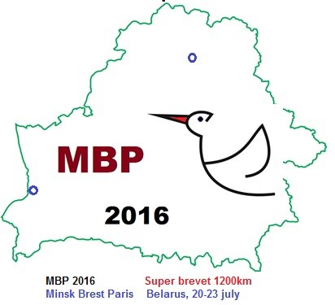

1st ACP 1200+km Super-brevet in Belarus (B1200) is the cycling contest of endurance on the course of more than 1200 km in 90 hours!

B1200 is held by the Cycling club “Siabry Randonneurs” (Minsk)
- according to the developed Rules [1];
- based on АСР goals, concepts, General rules of ACP brevets [2].

Please, pay your attention, that B1200 Route is designed so that shortened section of a route from Control Point 0 to Control Point 9 (Minsk-Brest-Paris) may be reckoned as B1000 (1000km brevet) under the condition of participant’s exempting from the Brevet in Paris.

According to the results of reconnaissance rides and other brevets in 2012-2016 very interesting places in Belarus were chosen for B1200 Route [3]: national parks, nature reserves, museums, castles, etc.
The Organizers’ Team and the Volunteers’ team will provide the necessary services to the Participants [4].

According to the developed Rules [1]:
- To take part in B1200 you have to ride successfully in 2016 ACP brevets for a total distance at least 600 km;
- correspondence registration is carried out from 01.05.2016 till 15.06.2016: participants have to fill up the obligatory Form [5]
(the Form data is very important for services panning [4] and for the Volunteers’ on the Controls)
- starting registration for B1200 begins in Start Point on 20.07.2016 at 00:00 a.m. and ends on 20.07.2016 at 01:40 a.m.;
- participants, who need their things to be delivered to certain Rest Points (according to the Form data) will hand over their signed packages with those things to the Volunteers at the Start;
- the Start is from 2:00 a.m. 20.07.2016 (Wednesday);
- the Finish closing time in Minsk is 08:00 p.m. 23.07.2016 (Saturday);
- after B1200 the Protocol for ACP approval and homologation will be formed, medals and certificates will be ordered (issue will be in the end of the year).

B1200 participation fee depends on the services number [4] chosen in the Form [5].

Dear Randonneurs! Please learn the Route [3], Points of Interest, Services [4], fill in the Form [5] and.... WE WELCOME YOU TO TAKE PART IN B1200!
Any questions (if necessary) please send on Club’s e-mail [6] .

This Notice is the invitation to take part in the 1st ACP 1200+km Super-brevet in Belarus (B1200) !

References:
[1] B1200 Rules: https://sites.google.com/site/sabryrandonneery/polozenie/polozenie-o-super-brevete-1200km-b1200-minsk-brest-pariz-minsk-mbp-2016
[2] General Rules of ACP-events in Belarus: https://sites.google.com/site/sabryrandonneery/polozenie/polozenie-o-provedenii-brevetov-v-rb
[3] B1200 Route and Controls: http://www.gpsies.com/map.do?fileId=wkfvlgdeaxwcupis
[4] B1200 Services:
https://docs.google.com/spreadsheets/d/115zdO4bsULVcdVm12T7dNtIEcDdhl0KGtzWmOz8Vwvw/edit#gid=0
[5] Participant’s questionnaire:
https://docs.google.com/forms/d/1zbFSPQ7tAIPiggta33itL82DJQReLqkA51m4QlkTyJ8/viewform
[6] Contacts:
ACP Representative in Belarus:
siabry.randonneurs@gmail.com

