From: Jean-Gualbert FABUREL…
Date: 2013/1/27
Subject: Fleches Nationales / National Arrows - Randonneur 5000 - Randonneur 10000
To: …
Hello,
I would like to inform you that we modified our organization for the homologation of the National Arrows. To increase our service level and speed up the homologation process, two people will work on that subject, Suzanne Lepertel and Sophie Matter. I will dispatch the homologations to her, depending on their load and availability. That’s why you will have to send me your results and no more to Suzanne Lepertel directly.
You will find also attached the new rules for the Randonneur 5000 and the Randonneur 10000. You will have to collect locally all the requests and send them to Geneviève Faburel. We will send you all the awards and diplomas and you will dispatch them in your country. We don’t ask you anymore international reply coupons. The difference between the price you paid for them and the price we get from them is very important. It’s a major waste of money. We will only invoice you the shipping costs from France to your country on your annual invoice. Of course, you can ask to your riders to pay you something locally to pay your local shipments.
We are going to open a Paypal account for your annual invoices. It could be easier and cheaper for you.
Feel free to contact me for any question about those modifications.

Bonjour,
Je vous informe que nous avons modifié notre organisation pour l’homologation des Flcèhes Nationales. Pour améliorer la rapidité de nos homologations, deux personnes seront maintenant en charge de ce sujet, Suzanne Lepertel et Sophie Matter. Je leur distribuerai les résultats, suivant leur charge et leur disponibilité. C’est pourquoi je vous demande de m’envoyer dorénavant vos résultats, donc de ne plus les envoyer directement à Suzanne Lepertel.
Vous trouverez en pièce jointe les nouvelles règles pour le Randonneur 5000 et le Randonneur 10000. Vous aurez à centraliser toutes les demandes de votre pays et à les envoyer à Geneviève Faburel. Nous vous enverrons les médailles et les diplômes et vous les distribuerez dans votre pays. Nous ne vous demanderons plus de coupons-réponse internationaux. La différence entre votre coût d’achat et la somme que nous obtenions était parfois très élevées. C’est une perte d’argent importante pour vous. Nous vous facturerons uniquement les frais d’expédition de la France vers vous sur votre facture annuelle. Bien sûr, vous êtes libres de demander localement un paiement de vos frais de distribution locaux.
Nous allons également ouvrir un compte Paypal pour ceux qui souhaitent passer par ce système pour payer leur facture annuelle. Ceci pourrait être plus simple et moins cher.
Merci de me contacter pour toute question sur ces deux modifications.
Best regards,
Jean-Gualbert FABUREL, Audax Club Parisien, 2 rue des aulnes
78920 ECQUEVILLY, +33 1 34 75 98 57

AUDAX CLUB PARISIEN

RANDONNEUR 5000

REQUEST FORM
(to be filled in block letters PLEASE)
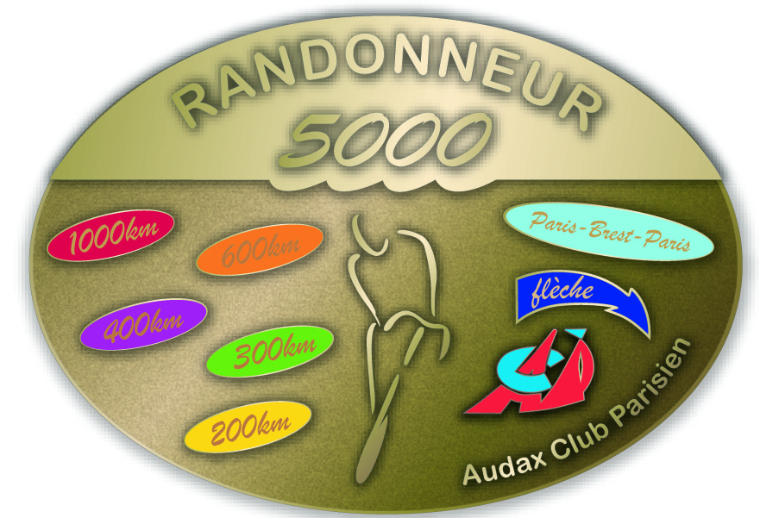
RANDONNEURS FRANÇAIS 1921
RANDONNEURS EUROPEENS 1976
RANDONNEURS MONDIAUX 1983

LAST NAME …………………………..………… First Name ……………….…………….… Birth date …. / …. / ……..…

Address ……………………………………..……….…………………………….………………………………………………………………

ZIP Code …………..………. City ………………………………..….………….………… Country / State…………...……………………

CLUB …….…….……………………………………………………………………….…………….….……ACP Code …..………..……..…
(NO abbreviations)

Date of First Event ….....… / ………… / …………… Date of Last Event ….…… / ………… / ……………

Events | Brevet | Date | Name of the organiser  or name of the event | Certification number
Brevets de  Randonneurs  Mondiaux | 200
Brevets de  Randonneurs  Mondiaux | 300
Brevets de  Randonneurs  Mondiaux | 400
Brevets de  Randonneurs  Mondiaux | 600
Brevets de  Randonneurs  Mondiaux | 1000
PBP | 1200 |  | AUDAX CLUB PARISIEN
Flèche Vélocio
or National arrow

Balance of Required Kilometers

Events | Distance | Date | Organizer  or Name of Event | Certification number
Brevets de
Randonneurs
Mondiaux
Brevet 1200 & +
Flèches de France
Flèche
Trace
National arrow

KILOMETERS TOTAL :

AUDAX CLUB PARISIEN

RANDONNEUR 10000

REQUEST FORM
(to be filled in block letters PLEASE)

RANDONNEURS FRANÇAIS 1921
RANDONNEURS EUROPEENS 1976
RANDONNEURS MONDIAUX 1983

LAST NAME …………………………..………… First Name ……………….…………….… Birth date …. / …. / ……..…

Address ……………………………………..……….…………………………….………………………………………………………………

ZIP Code …………..………. City ………………………………..….………….………… Country / State…………...……………………

CLUB …….…….……………………………………………………………………….…………….….……ACP Code …..………..……..…
(NO abbreviations)

Beginning date of First Event : ….....… / ………… / ……… End date of Last Event : ….…… / ………… /……………..
(Dates : dd/mm/yyyy)
Events | Distance (km) | Date | Name of the organiser  or name of the event | Certification number
Brevets  Randonneurs  Mondiaux | 200
Brevets  Randonneurs  Mondiaux | 200
Brevets  Randonneurs  Mondiaux | 300
Brevets  Randonneurs  Mondiaux | 300
Brevets  Randonneurs  Mondiaux | 400
Brevets  Randonneurs  Mondiaux | 400
Brevets  Randonneurs  Mondiaux | 600
Brevets  Randonneurs  Mondiaux | 600
Brevets  Randonneurs  Mondiaux | 1000
Brevets  Randonneurs  Mondiaux | 1000
Brevets  Randonneurs  Mondiaux | 1200 |  | PARIS-BREST-PARIS
BRM 1200+
Flèche Vélocio/Nationale Arrow
Super Randonnée | 600
Balance of Required Kilometers
Brevets
Randonneurs
Mondiaux
BRM 1200+
Flèche Vélocio/Pascale
National Arrow
Flèches de France |  |  | Flèche :
Flèches de France |  |  | Flèche :
Super Randonnee

KILOMETER TOTAL :


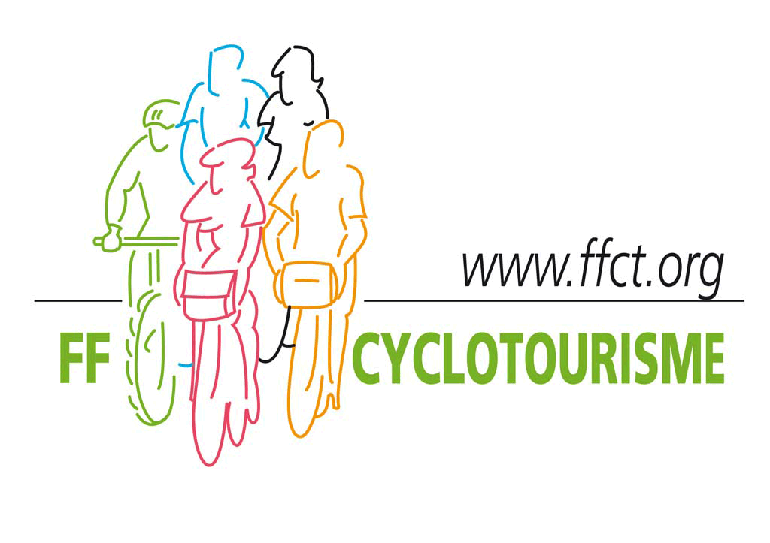

RANDONNEUR 5000

________________________

In 1961 the AUDAX CLUB PARISIEN created an award for those randonneurs who have completed 5000 KM in BRM events. This award is called the Randonneur 5000.
Awarded randonneurs receive the R-5000 medal and diploma. They are numbered from the beginning.

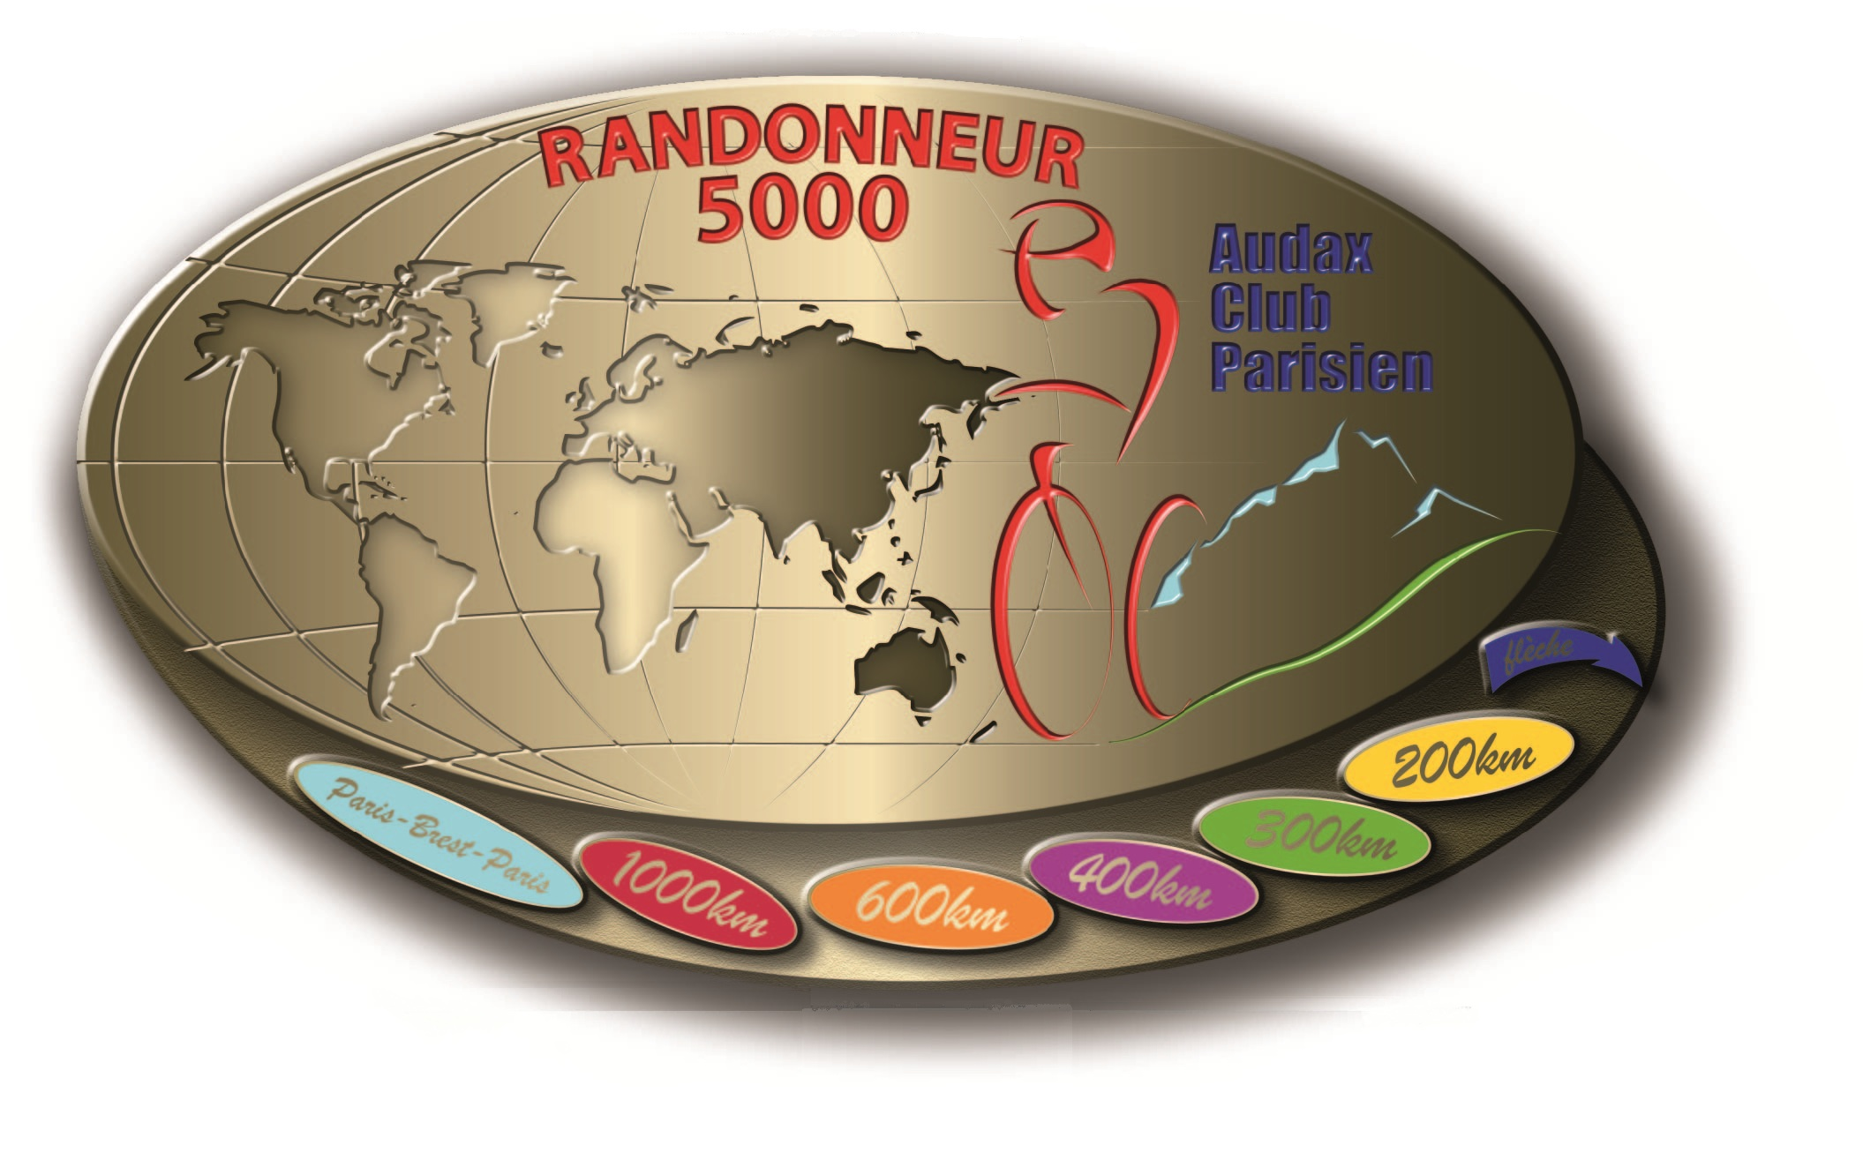
QUALIFICATIONS: To qualify for this award, the randonneur must complete :

the full series of ACP brevets (200, 300, 400, 600 and 1000km)
Longer brevets cannot be substituted for shorter ones.

1 PARIS-BREST-PARIS Randonneur

- 1 FLECHE VELOCIO
The achieved mileage is used (i.e. if the team went further than the minimum qualifying distance of 360 km).At least 3 riders must finish the Flèche (you cannot individually claim for your ridden mileage if your team was not successful).
International randonneurs can ride a Flèche Nationale homologated by the ACP and organized in accordance with the rules for the Flèche Vélocio.

- Additional ACP events to bring the total distance up to at least 5000 km

Following events are accepted :

- Flèches de France (ACP permanents), if they are ridden on one of the established routes and in the Gold or Silver division. The Flèche de Dieppe is not acceptable since it is shorter than 200 km.
- Brevets de Randonneurs Mondiaux (BRMs)

- 1200 + events homologated by Les Randonneurs Mondiaux. These 1200 km events cannot take the place of the ACP 1000 km brevet.- Flèche Vélocio or Pascale or Nationale

- Flèches Vélocio or Flèches Pascales or Flèches Nationales
- Traces Vélocio or Traces Pascales (Darts)

The qualifying events must be completed within a four year period, beginning on the date of the first qualifying event.

HOW TO APPLY :

Send your request form per mail or email before October 31 (even in the PBP years).
For France: applications must be accompanied by an envelope size 32/23 with the address of the applicant and stamped for a 500g letter unless you come to the Awards Ceremony of the ACP which takes place every year in January in Paris.
For other countries : applications will be compiled and verified by the local ACP representative, who will send them via Internet using a "Word" format. All medals and diplomas will be sent to the ACP representative who will distribute them to each winner. Shipping between France and the country will be added to the annual invoice.
The medal, the diploma and the ACP results brochure will be sent to you in January.

The ACP reserves the right to amend those rules.

________________________________________________________________________

CONTACT :

« RANDONNEUR 5000 »

Geneviève FABUREL, 2 rue des aulnes, 78920 ECQUEVILLY
genevieve.faburel@audax-club-parisien.com

www.audax-club-parisien.com 2013, February1st

RANDONNEUR 10000
________________________

Fifty years after the RANDONNEUR 5000, the AUDAX CLUB PARISIEN creates a new award for those randonneurs who have completed 10,000 km in ACP events. This award is called the Randonneur 10000. Awarded randonneurs receive the R-10000 medal and diploma. They are numbered from the beginning.

QUALIFYING EVENTS

The qualifying events must be completed within a six year period, beginning on the date of the first qualifying event.

To qualify for this award, the randonneur must complete :

2 full series of ACP brevets (200, 300, 400, 600 and 1000 km) - Longer brevets cannot be substituted for shorter ones

1 PARIS-BREST-PARIS Randonneur

Another 1200 km + event homologated by Les Randonneurs Mondiaux
- 1 FLECHE VELOCIO or National arrow
The achieved mileage is used (i.e. if the team went further than the minimum qualifying distance of 360 km).
At least 3 riders must finish the Flèche (you cannot individually claim for your ridden mileage if your team was not successful).
International randonneurs can ride a Flèche Nationale homologated by the ACP and organized in accordance with the rules for the Flèche Vélocio.

1 SUPER RANDONNEE i.e. a permanent of 600 km and at least 10,000 m (32.800 ft) of climbing, homologated by the Audax Club Parisien, ridden in the Randonneur division.
No Brevet can be substituted for another.
The events used to apply for the Randonneur 5000 can be used to apply for the Randonneur 10000.

To bring the total distance up to at least 10,000 km, following ACP events are accepted :

- Brevets des Randonneurs Mondiaux (BRMs).
- 1200+ events homologated by Les Randonneurs Mondiaux. These 1200 km events cannot take the place of the ACP 1000 km brevet.
- Flèches Vélocio or Flèches Pascales or Flèches Nationales.
- Super Randonnee.
- Flèches de France (ACP permanents), if they are ridden on one of the established routes and in the Gold or Silver division. The Flèche de Dieppe is not acceptable since it is shorter than 200 km.

HOW TO APPLY
Send your request form per mail or email before October 31.
For France: applications must be accompanied by an envelope size 32/23 with the address of the applicant and stamped for a 500g letter unless you come to the Awards Ceremony of the ACP which takes place every year in January in Paris.
For other countries : applications will be compiled and verified by the local ACP representative, who will send them via Internet using a "Word" format. All medals and diplomas will be sent to the ACP representative who will distribute them to each winner. Shipping between France and the country will be added to the annual invoice.

The medal, the diploma and the ACP results brochure will be sent to you in January.
The ACP reserves the right to amend those rules.

____________________________________________________________________________

CONTACT :

« RANDONNEUR 10000 »

Geneviève FABUREL, 2 rue des Aulnes, 78920 ECQUEVILLY, France - Tél. : +33 (0)1 34 75 98 57
R10000@audax-club-parisien.com

www.audax-club-parisien.com February 2013

