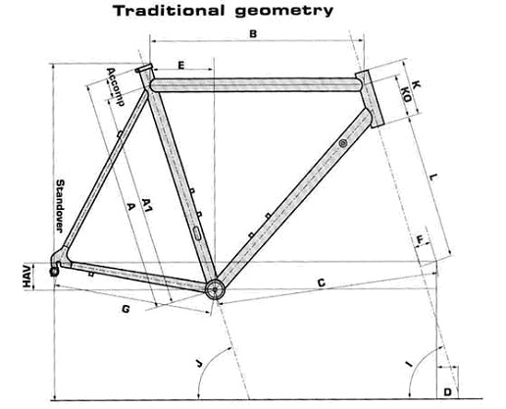
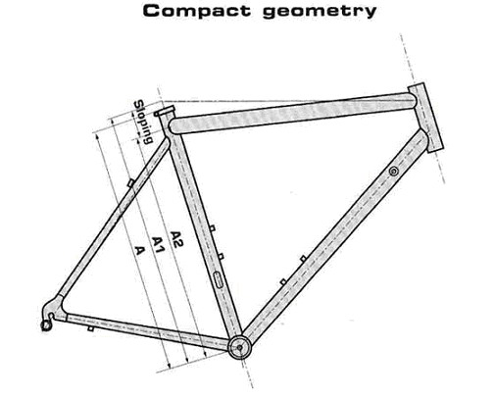

 | Axe-axe real | Axe-axe virtual | Axe-high | LOOK 486 |  |  |  |  |  |  |  |  |  |  |  |  |  |  | Standover
H | A2 | A1 | A | Accomp | Slop | B | B' | C | D | E | F | G | HAV | I | J | K | KO | L
XS(49) | 425 | 490 | 463 | 38 | -65 | 520 | 507 | 575 | 67,6 | 129 | 43 | 408 | 70 | 71,5 | 74,75 | 105 | 68 | 368 | 707
S(51) | 460 | 510 | 498 | 38 | -50 | 530 | 519 | 578 | 64,4 | 138 | 43 | 408 | 70 | 72 | 74,25 | 125 | 88 | 368 | 734
M(53) | 495 | 530 | 533 | 38 | -35 | 540 | 530 | 577 | 58,2 | 146 | 43 | 408 | 70 | 73 | 74 | 148 | 111 | 368 | 763
L(55) | 530 | 550 | 568 | 38 | -20 | 560 | 555 | 593 | 58,2 | 156 | 43 | 408 | 70 | 73 | 73,5 | 156 | 119 | 368 | 782
XL(57) | 570 | 570 | 628 | 58 | 0 | 575 | 575 | 603 | 58,2 | 167 | 43 | 408 | 70 | 73 | 73 | 175 | 138 | 368 | 811
XXL(59) | 590 | 590 | 648 | 58 | 0 | 590 | 590 | 618 | 58,2 | 172 | 43 | 408 | 70 | 73 | 73 | 198 | 161 | 368 | 831

