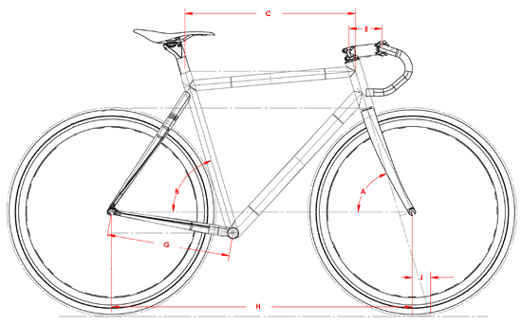

Рама XL ( 58cm) С- 56 cm; G- 40.5 cm; H – 100 cm; Е – 12.5 cm.

