[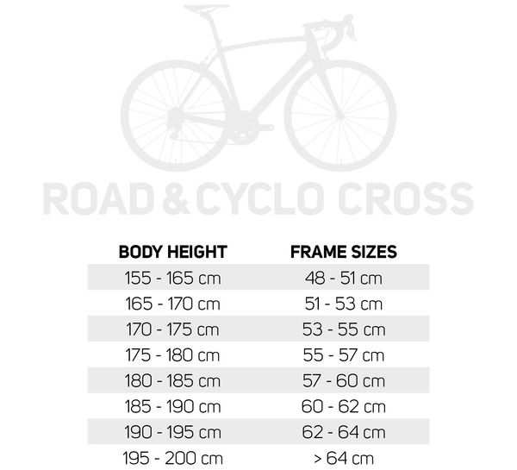](http://www.merida-bikes.com/en_int/bikes/road-fitness/2016/609-bikefinder.html)